PSSI Science Project Reporting Template

️ | The PSSI Implementation Team is compiling a technical report to demonstrate the important research and advancements made by the Science Branch through the PSSI funding. The technical report will include a 3-4 page summary (including graphics and figures) for each project to show their key results and findings. Please fill in the following fields and sections for your project to be included in the report. Feel free to include and draw from any reports or presentations previously created through your research.  A plain language science bulletin will also be created to follow up on last year’s “DFO Pacific Region Science Bulletin, 2024. New research and monitoring for Pacific salmon and their ecosystems.” While the first bulletin introduced project backgrounds, methods, and timelines, this new bulletin will highlight the projects’ results, key findings, and conclusions with links to reports and data available. The bulletin will include a 1-2 page summary for each project gleaned from the content entered below.  ️ Completed forms are due January 7, 2026.  *Please include or send separately any graphics or pictures (with photo credits) that will help promote the projects.

PART 1: PROJECT METADATA

General Project Information
Project ID (number) | Project Title
2400 | Assessment of SEP Chinook and Coho broodstock ELISA screening data by modelling for explanatory variables, and yearling DFAT prevalence data by modelling for predictive variables.
Project Leads | Collaborations and External Partners
Amy Long | Derek Price, DFO  Ian Keith, DFO  Cheryl Lynch, DFO
Location (if applicable) | Derek Price, DFO  Ian Keith, DFO  Cheryl Lynch, DFO
Pacific | Derek Price, DFO  Ian Keith, DFO  Cheryl Lynch, DFO

Geographic and Stock Information
Salmon species (if applicable) | Waterbodies (if applicable)
Chinook salmon (Fall, Spring, and Summer)  Coho salmon (Fall) | Click or tap here to enter text.
Life history phases (if applicable) | Region
Juveniles, broodstock | Pacific
Stock (if applicable) | Population (if applicable)
Puntledge, Nitinat, Coldwater River, Spius Creek, Nicola River, Chilcotin River, Chilko Ricer, Salmon River, Eagle River | Click or tap here to enter text.
Conservation Unit (if applicable)
Click or tap here to enter text.

🧰 PART 2: PROJECT METRICS

Project Outputs
Include any anticipated outputs denoted as (in progress). Please include links to any outputs available online so they can be referenced in the report.
List scientific publications and technical reports (with links)
Click or tap here to enter text.
List datasets generated (with links)
Click or tap here to enter text.
Describe dataset locations and data management systems
Click or tap here to enter text.
List code, programs, or other software created (with links)
Click or tap here to enter text.
List communication or social media products
Click or tap here to enter text.
List and describe field work completed
Click or tap here to enter text.
List and describe samples collected/analyzed (number of samples)
Click or tap here to enter text.
List and describe large capital assets or equipment acquired

PART 3: WRITTEN CONTENT

Highlights
Please summarize in 2-3 bullets:
- The main idea of the project
- Key findings
- Implications of these findings for salmon and decision-makers
- For a more technical audience, but still as plain language as possible
- The study explored the relationship between parental BKD levels on individual salmon results while controlling for the impact of environmental factors such as thermal regime using previously collected data including broodstock disease levels, environmental parameters, and progenitor disease status.
- BKD levels in returning adults do not demonstrate a significant association with the OD levels of their progenitors. Instead, the relationship appears to be confounded by environmental and population-level factors, including water temperature, specific watershed characteristics, and the overall BKD prevalence within the returning population.
- The findings reveal key knowledge gaps in understanding BKD dynamics, suggesting the need for further research to build a fuller picture of the factors influencing disease transmission and prevalence.

Background
Please provide 1-2 paragraphs to summarize
- The relevant biological, environmental, and/or management context
- What knowledge gap or demand were you trying to fill?
- Collaboration and partner relationships
Renibacterium salmoninarum, the causative agent of bacterial kidney disease (BKD), is endemic to the Pacific Northwest. Infection with this bacterial pathogen can result in significant morbidity and mortality in cultured juvenile Pacific salmon. Current BKD management relies on screening brood stock using an enzyme-linked immunosorbent assay (ELISA) and excluding eggs from females exceeding the defined optical density (OD) threshold. This approach has significantly reduced the incidence of disease in both hatchery-reared juveniles and returning adult fish. The Salmonid Enhancement Program (SEP) maintains an extensive dataset that includes 16 years of ELISA broodstock screening results for many Vancouver Island and mainland Coho and Chinook stocks.
These datasets have not been previously subjected to a comprehensive epidemiological analysis to identify potential explanatory variables for BKD prevalence in stocks of concern. This project sought to address that knowledge gap by integrating ELISA data and linking broodstock ELISA values to Parental Based Tagging (PBT) information enabling stock-specific analyses. The work was conducted through a collaborative partnership among the Science Branch, SEP, and Aquaculture Management.

️ Methods and Findings
Please insert a few paragraphs to summarize:
- Main methods used
- Products and tools produced
- Advancements in methodology, technology, and application
- Advancements in communication and knowledge transfer
- Key results and information generated
Methods
The study explored the relationship between parental BKD levels on individual salmon results while controlling for the impact of environmental factors such as thermal regimes by incorporating various temperature metrics, such as average temperature, minimum and maximum temperatures, degree days, and the number of days within specific temperature thresholds (6°C to 10°C). While Nitinat's temperature data was based on monthly or daily mean temperatures (depending on the year), Puntledge and Spius provided daily mean, maximum, and minimum temperatures. For each stock year, temperature data were filtered to include dates that a stock occupied the hatchery, e.g. the day of first broodstock captured to the day of last juvenile release. Juveniles of Chinook stocks were released less than a year of holding at the hatchery at Puntledge and after two years at Spius, while Coho stocks were released after 1 year and 2 year but temperature measurements were calculated based on the 2 year release for Coho stocks.
Data used in the analysis was from 2014 through 2023, and was dependent on data available in E-PRO and temperature data (Table 1). Only individuals with BKD value and maturity class information were included. Incomplete data points were filtrated out in each analysis. Dam’s BKD optical density (OD) value and BKD level were attached to E-PRO records for progenies by matching progenies’ dam DNA code to the dam’s data in the report. This step was only possible for progenies with dam’s DNA code and BKD OD value.
To guide the modelling of the vertical transmission path, we collaborated with an expert panel to develop a causal diagram (Figure 1). This exercise facilitated the identification and characterization of relationships across multiple scales, including the watershed, hatchery, and individual fish levels, while specifically assessing variables for their potential to confound the results. We evaluated these factors using a mixed-effects generalized linear model framework, designating the OD from the BKD ELISA as the outcome of interest and the OD of the progenitor (the dam) as the primary predictor. Temporal variation was integrated as a random effect to account for annual fluctuations. The final model incorporated several confounding factors, most notably the specific watershed of origin. We also included terms for interactions between mean temperature—which was scaled and centered by creek—and BKD prevalence at the stock level. For the purposes of this analysis, a stock was defined as a cohort of brood fish of the same species returning to the same creek during the same season, such as Nitinat Spring Coho. While species and season were initially tested, they were excluded from the final model as they were not statistically significant and did not meet the criteria for confounders; their observed effects were largely captured by spatial and temporal variables.
Research Findings
The primary analysis indicates that BKD levels in returning adults do not demonstrate a significant association with the OD levels of their progenitors. Instead, the relationship appears to be confounded by environmental and population-level factors, including water temperature, specific watershed characteristics, and the overall BKD prevalence within the returning population. For instance, while the watershed variable was not statistically significant in isolation, its inclusion in the model resulted in a measurable change in the coefficient of the primary predictor, suggesting a latent environmental influence. A more notable finding was the negative association between BKD levels and scaled temperature, which suggests that OD levels generally decrease as temperatures increase. However, a significant interaction between temperature and BKD prevalence indicates a modulating effect on this relationship (Figure 2). While lower temperatures appear to provide a more suitable environment for the transmission of BKD, a higher proportion of infected individuals within a population further intensifies this effect.
It is important to note, however, that the statistical model demonstrated a relatively low goodness-of-fit, indicating that a substantial portion of the variance in BKD levels remains unexplained by the variables currently under study. This suggests that the dynamics of BKD in these ecosystems are influenced by a complex array of factors—potentially including individual host immunity, varying hatchery practices, or additional environmental stressors—that were not fully captured in the present framework. Consequently, while the identified trends regarding temperature and prevalence offer valuable directional insights, they should be interpreted with caution and viewed as preliminary findings within a highly variable biological system.

Insights
Please insert a few paragraphs to summarize:
- What this project has added to knowledge about salmon populations, health, or ecosystems.
- How this project informs salmon management:
  - decisions
  - policy guidance
  - trade-offs
  - planning
- Addition of knowledge to understanding:
  - limiting factors/stressors/threats/ pathways of effects/risks
  - biologically significant thresholds
  - cumulative impacts
- Sources of uncertainty
This project contributes significant clarity to the understanding of BKD transmission by identifying that environmental and population-level factors often overshadow direct parent-to-offspring transmission in wild and enhanced stocks. By demonstrating that BKD levels in returning adults are more closely associated with watershed characteristics and thermal regimes than with the status of their progenitors, this research shifts the focus toward environmental stressors as primary drivers of disease expression. These findings highlight a critical pathway of effect where colder water temperatures facilitate higher pathogen loads, a relationship that is further intensified by the cumulative impact of high disease prevalence within the population. This identification of thermal and density-dependent "modulating effects" provides a more nuanced understanding of how multiple stressors interact to influence the health of salmon cohorts.
From a management and policy perspective, these insights inform risk assessment and hatchery planning by emphasizing that individual-level screening of broodstock may be insufficient without considering broader ecological context. The study provides a framework for evidence-based decisions regarding stock transfers and watershed-specific management, suggesting that biologically significant thresholds for disease may vary depending on local environmental conditions. By accounting for these spatial and temporal variables, managers can better navigate the trade-offs between enhancement goals and the risks of disease outbreaks.
A primary source of uncertainty in this analysis, however, stems from the operational protocols used to manage BKD in hatcheries. The standard practice of utilizing OD thresholds to cull high-risk eggs creates a filtered data set, as the most heavily infected vertical transmission paths are often removed from the population before they can be assessed in returning adults. Furthermore, when conservation concerns for at-risk populations supersede these culling protocols, it introduces additional variability into the transmission pathway. This management-induced selection bias limits our ability to fully quantify the role of vertical transmission, as the observed returning population primarily represents individuals that either passed through a selective screening process or were spared due to conservation priorities.

⏩ Next Steps
Please insert 1-2 paragraphs to summarize:
- Remaining knowledge gaps and recommendations for future studies
- How can/should the project findings be operationalized for salmon conservation and management?
The findings reveal key knowledge gaps in understanding BKD dynamics, suggesting the need for further research to build a fuller picture of the factors influencing disease transmission and prevalence. The low goodness-of-fit of the current model indicates that additional variables, such as hatchery practices, genetic diversity, or other environmental and anthropogenic stressors, may play significant roles in shaping BKD dynamics. A promising avenue for research includes the use of simulation models to assess the impact of altering management practices, such as raising or lowering the positive-negative culling threshold OD value. This approach could help predict how adjustments to culling thresholds might influence disease prevalence and population outcomes under varying environmental conditions. Research should also focus on understanding potential thresholds or tipping points where environmental conditions, such as temperature extremes, significantly influence disease prevalence and outcomes.
The study’s findings can inform proactive strategies for salmon conservation and management, particularly concerning how environmental conditions affect BKD prevalence. Managers could prioritize monitoring in watersheds where conditions, including temperature and BKD prevalence, elevate disease transmission risks. Additionally, the insights from simulations examining the effect of changing the positive-negative culling threshold OD value could guide policy and operational decisions to strike a balance between limiting disease spread and optimizing population sustainability.

📈 Tables and Figures
Please provide captions and numbering for any tables and figures. Graphics can be copied below or e-mailed separately.
- Include a brief caption with each figure and table in the box below
- Number each table and figure, and include references in the above sections where appropriate.
- 1-3 figures are recommended per project

Table 1. Stocks and cohorts used in this analysis as well as the years of available data for BKD screening, progenitor DNA, and temperature.
Stock Name | Cohort | BKD screening | Progenitor DNA | Temperature Data
Puntledge Fall Coho | * | 2018, 2020 | None | 2014-2023
Puntledge Summer Chinook | * | 2014-2023 | 2017-2023 | 2014-2023
Nitinat Fall Coho | * | 2014-2022 | 2016-2020, 2022 | 2014-2023
Coldwater River Spring Chinook | Spius 1 | 2014-2023 | 2019, 2022, 2023 | 2017-2022
Spius Creek Spring Chinook | Spius 1 | 2014-2023 | 2019, 2022, 2023 | 2017-2022
Nicola River Spring Chinook | Spius 1 | 2014-2023 | 2019-2022 | 2017-2022
Chilcotin River Spring Chinook | Spius 3 | 2021, 2022 | None | None
Chilko River Summer Chinook | Spius 4 | 2014-2023 | 2021 | None
Coldwater River Fall Coho | Spius 1 | 2014-2023 | 2017, 2020-2022 | 2017-2022
Spius Creek Fall Coho | Spius 1 | None | None | 2017-2022
Salmon River Fall Coho | Spius 2 | 2014-2015, 2017-2023 | 2017-2018, 2020, 2022-2023 | None
Eagle River Fall Coho | Spius 5 | 2015-2023 | 2018-2020, 2022 | None

Figure 1. Directed Acyclic Graph (DAG) of the causal web explaining OD results for BKD. Arrows represent plausible unidirectional associations between factors considered for the epidemiological model as identified and characterized by the experts panel.

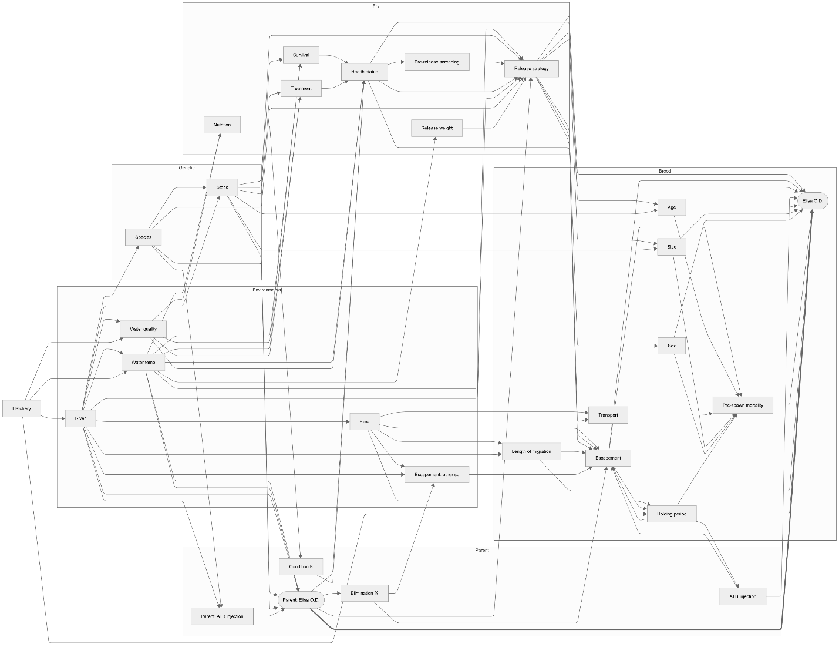

Figure 2. Interaction between the effects of Scaled Temperature and BKD Prevalence. Predicted values are derived from our linear mixed-effects model accounting for year to year variation. The scaled temperature is plotted on the x-axis against the OD for BKD (y-axis), with separate lines representing 20% (red) and 80% (blue) BKD prevalence in the returning population. Shaded regions of corresponding colours represent 95% confidence intervals.

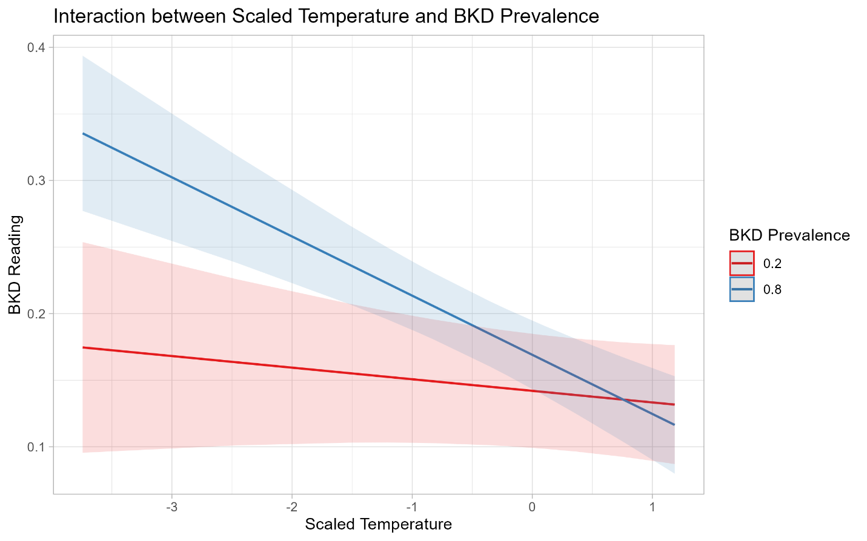

📈 References
Include full references for any publications referenced in other sections. Please format references in Harvard style according to Instructions to Authors for the Canadian Journal of Fisheries and Aquatic Sciences, at Canadian Science Publishing.
Click or tap here to enter text.

